# Work Breakdown Agreement Assignment 1

Kelvin:

UML Diagrams (Brief Copy)

Providing documentation of UML Diagram understanding

Sequence Diagrams (Brief Copy)

Proofreading of Sequence diagrams

Flowcharts

Github committing 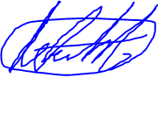

Matt:

Sequence Diagrams (Brief Copy)

Providing documentation of Sequence Diagram understanding

Proofreading of UML diagrams

Writing the WBA

Github committing

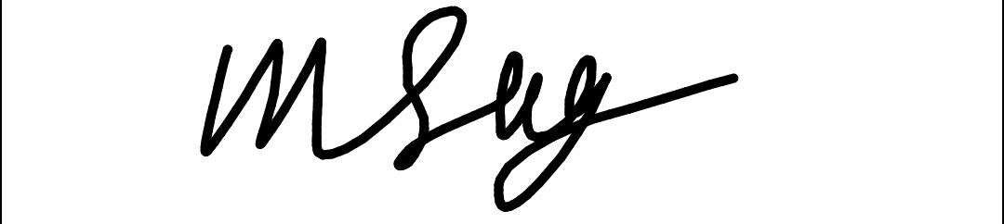

# Work Breakdown Agreement Assignment 2

Kelvin:

Check the classes

Help each other understand template code

Write Droid code

Write documentation of Assignment 2

Github committing

Matt:

Apply classes to the Star Wars code

Help each other understand template code

Write Humanoid code

Write Control and Train code

Writing the WBA

Draw classes for UML and Sequence Diagrams

Github committing

# Work Breakdown Agreement Assignment 3

Kelvin:

Check the classes

Implement Stormtroopers feature

Implement Darth Vader and Princess Leia

Help each other understand template code

Write documentation of Assignment 3

Github committing

Matt:

Apply classes to the Star Wars code

Help each other understand template code

Writing the WBA

Draw classes for UML and Sequence Diagrams

Github committing